Conference Travel Discounts from United and Delta

Visit: https://www.united.com/en/us/meetingtravel
Valid Travel Dates: 07/20/2026 - 07/29/2026
Z Code/Agreement Code: ZS6U769784 (Enter this code in “Offer Code” field)

** Meeting attendee fares: 2%, 5%, or 7% discounts (depending on fare class) in most regions applicable for itineraries originating in almost every country worldwide.

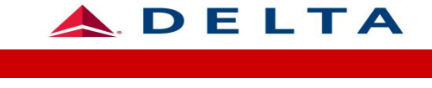
Visit: http://www.delta.com/
Valuda Travel Dates: 07/17/2026 – 07/31/2026
Meeting Code: NY4L2 (Enter in the “Meeting Code” field before you click “Find Flights”

**Discounts valid on DELTA BRANDED FARE - Delta One/ Delta First and Delta Premium Select /Delta Comfort 5% - 8% off.

