Participant Name: _________________________________ Birthdate: ___________Age: ______ Gender: _______
Grade: ____________ School: _______________________________________________ T-Shirt Size: ___________
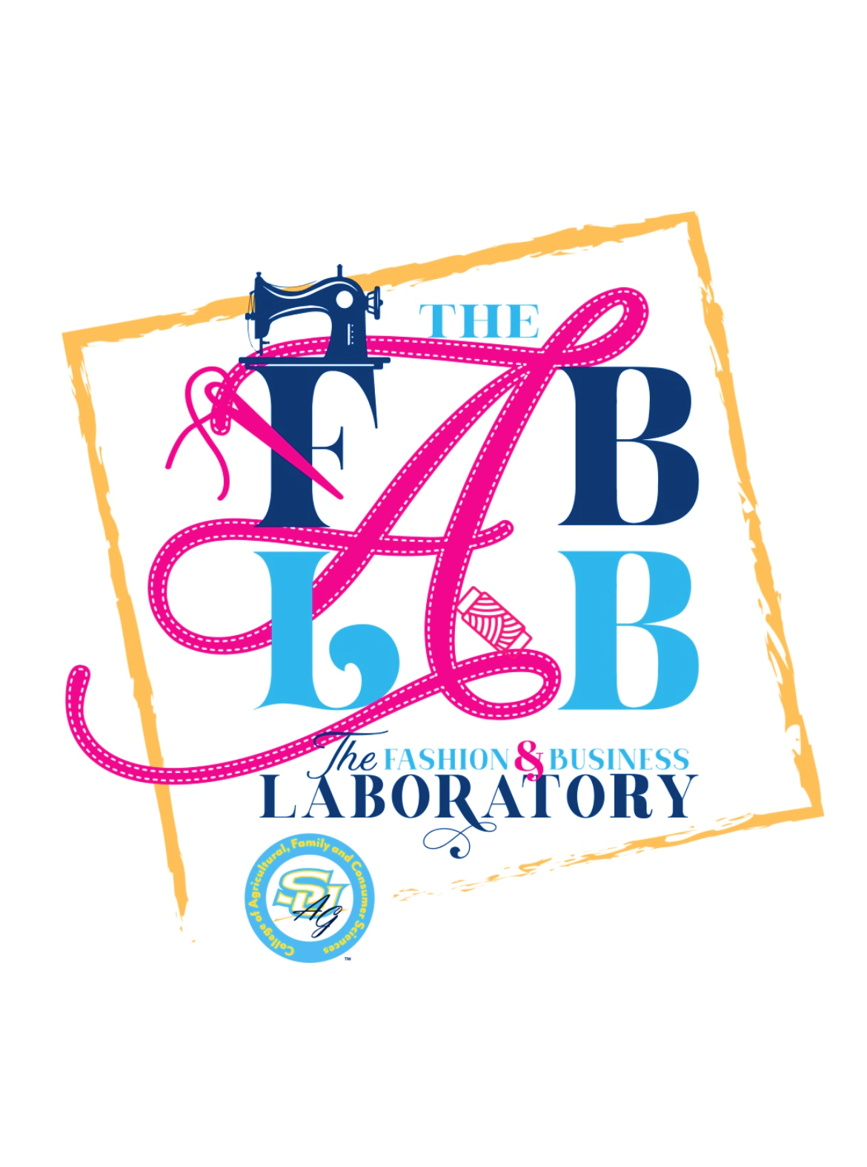
Address: ______________________________________________________________________________________
City: __________________________ Zip: _________________ Parish: ____________________________________
Email Address: _________________________________________________________________________________
Parent/Guardian’s Name: __________________________________________ Phone: _______________________
Emergency Contact’s Name: ________________________________________ Phone: _______________________
Additional Authorized Pick-Up Person (s): ___________________________________________________________
Allergies and/or Medical Conditions to be aware of: __________________________________________________
_____________________________________________________________________________________________
Waiver Agreement
Liability: I agree to release and hold harmless Southern University and A&M College, the Southern University Agricultural, Research and Extension Center, their successors, agents, trustees, assignees, officers, employees, representatives including the College of Agricultural, Human and Environmental Sciences, the SU Ag Center, and The FAB LAB employees and volunteers from any and all claims or liability to any accident that may arise as a result of participating in the FAB LAB Entrepreneurs Program.

I understand that sewing includes the use of machines, needles, scissors, irons and other tools and equipment. These activities include risks that can cause or lead to injury. If participant Is under the age of 18, I grant permission for my child to operate machines and use tools and equipment. I give permission for first aid and/or medical treatment to be given if the need arises.

Behavior: The FAB LAB reserves the right to withdraw a student from FAB LAB programs and events for inappropriate behavior. Due to the nature of working with machinery, the FAB LAB will not tolerate behavior deemed dangerous or harmful.

Photographic Release: I grant Southern University and A&M College, The Southern University
Agricultural, Research and Extension Center, The FAB LAB, their representatives, employees and
volunteers the right to take photographs of me and/or my child in connection with the FAB LAB. I authorize the entities stated above to copyright, use, and publish without mention of my or my child’s name the same in print and/or electronically. I agree that the entities stated above may use such photographs of me/my child for any lawful purpose, including for example such purposes as publicity, illustration, advertising, and Web content. I read and understand the above.

I certify that I have read the above waivers and agree to all terms. A parent or guardian must sign for children under the age of 18.

Participant Signature: _____________________________________________________ Date: ________________

Parent/Guardian Signature: ________________________________________________ Date: ________________

Please print, complete and bring this form to the first camp session or email to samii.benson@sus.edu

